SeaScape 2019 Temperature and Relative Humidity

*Compiled by Emily Barnes, UC Berkeley*

|  |  |  |
| --- | --- | --- |
|  | Temperature (⁰C) | Relative Humidity (%) |
| Minimum | 21.58 | 74.15 |
| 1st Quartile | 23.41 | 82.77 |
| Median | 24.15 | 86.04 |
| Mean | 24.12 | 86.19 |
| 3rd Quartile | 24.84 | 88.89 |
| Maximum | 27.18 | 100 |
| Standard Deviation | 1.03 | 5.22 |

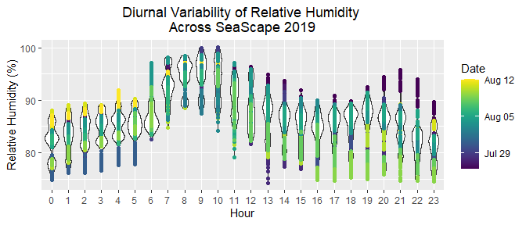

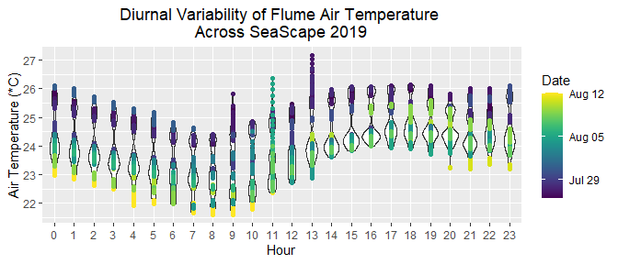

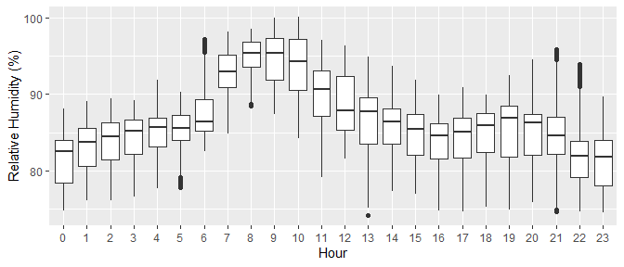

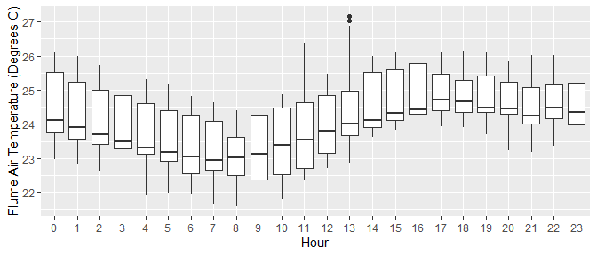

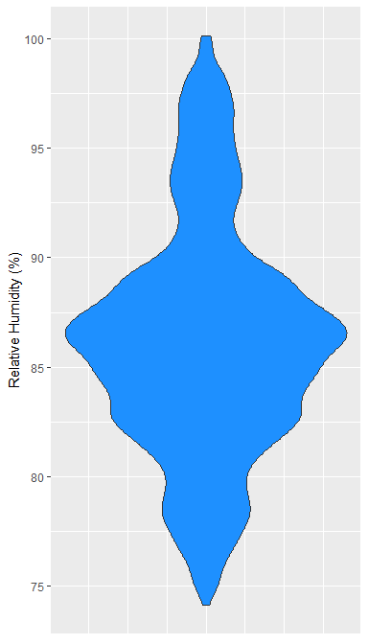 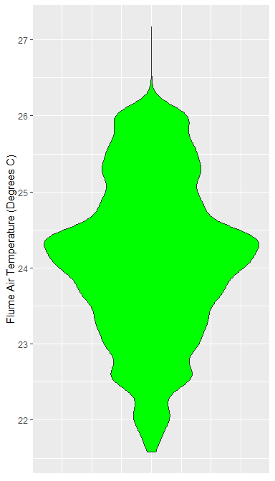

RH Probe Specs:

Visalia HMP9 RH probe, Insight version 1.0.2.76, sampled at upstream port in parallel with upstream CPC and trace gasses.

Please let me know if you would like cleaned versions of any figures